THEORY QUESTIONS
1.
a)

The diagram below is an illustration of a cocoa pod infected by a disease.
Study the diagram carefully and answer the questions that follow.
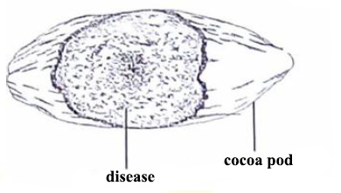
i)

Name the disease illustrated on the pod.
ii)

Mention the causative organism of the disease.
iii)

Describe one symptom of the disease.
iv)

State one farm practice that promotes the spread of the disease.
v)

Give one practices farmers could adopt to control the disease.
b)

The diagram below is an illustration of a cuboid with faces A, B and C shown and sides a, b and c indicated.
Study the diagram carefully and answer the questions that follow.
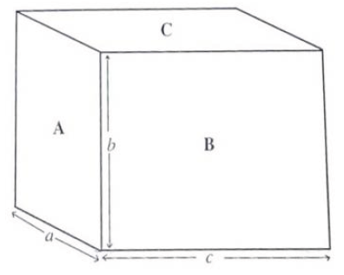
i)

Measure and record the length of each of the sides labelled a, b and c in centimeters.
ii)

Determine the area of each of the faces A and B.
iii)

If the weight of the cuboid is 100N, determine the pressure exerted by the cuboid in N/cm² when it lie on
α)

face A;
β)

face B.
iv)

From your results in (iii), explain how pressure exerted by a body changes with the area on which it lie.
c)

The diagram below is an illustration of three different types of teeth, labelled A, B and C in humans.
Study the diagrams carefully and answer the questions that follow.
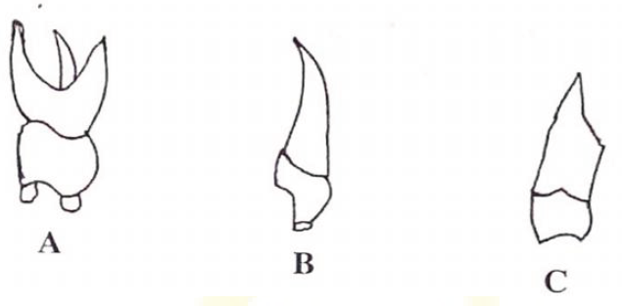
i)

Name each type of teeth labelled A, B and C.
ii)

State one function of the type of teeth labelled A, B and C.
iii)

State two observable differences between the tooth labelled A and that labelled B.
iv)

Mention two ways of ensuring proper dental care.
d)

The diagram below is an illustration of an experimental set-up used to separate water and salt from salt solution.
Study the diagram carefully and answer the questions that follow.
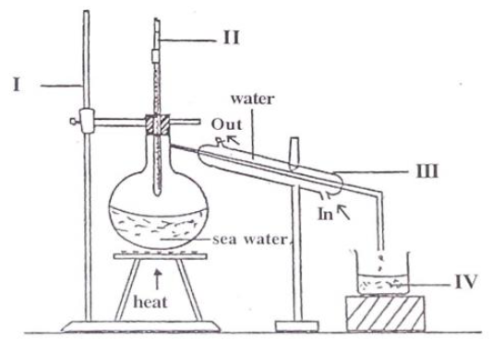
i)

Name each of the parts labelled I, II, III and IV.
ii)

Name the method of separation used.
iii)

State one function of each of the parts labelled II and III.
iv)

Name three physical processes that are involved in the separation of the mixture.

2.
a)

i)

What is technology?
ii)

State two differences between science and technology.
b)

Draw potassium atom and show the distribution of electrons in its shells.
[K= 19]
c)

What energy transformations take place in each of the following activities?
i)

Using a flashlight battery to produce light in a bulb.
ii)

Using a microphone to address a gathering.
d)

List three components of soil.

3.
a)

i)

Mention the junctions of a transistor.
ii)

Draw the circuit symbol for n-p-n transistor.
b)

State one function of the following parts of the human circulatory system:
i)

Blood;
ii)

Blood vessels;
iii)

Heart.
c)

Classify each of the following substances as element, compound or mixture:
i)

Air;
ii)

Brass;
iii)

Chlorine;
iv)

Gold;
v)

Water.
d)

State three ways of caring for farm machines.

4.
a)

i)

State two physical properties of water.
ii)

Using litmus paper, explain why water is neutral.
b)

Give one function of each of the following nutrients in plants:
i)

Nitrogen;
ii)

Potassium.
c)

i)

State two human activities that disrupt the carbon cycle.
ii)

State two effects of the disruption of the carbon cycle on the environment.
d)

i)

What is density of a body?
ii)

A body of mass 50kg has a density of 2kg/m³. Calculate the volume of the body.

5.
a)

What is vegetable crop?
b)

i)

What is air pollution?
ii)

State two humans activities that lead to air pollution.
c)

i)

List three modes of heat transfer.
ii)

Name the type of medium in which each mode of heat transfer you have listed in (i) takes place.
d)

Give three reasons why proteins are important in the diet of mammals.

6.
a)

State one function each of the following parts of the human reproductive system:
i)

Penis;
ii)

Ovary;
iii)

Oviduct;
iv)

Testis;
v)

Uterus;
b)

i)

What is electrical conductor?
ii)

List two substances which are insulators.
c)

State three ways of maintaining soil fertility.
d)

Write word equation for each of the following chemical reactions:
i)

Oxygen and hydrogens;
ii)

Nitrogen and hydrogen;
iii)

Sodium and chlorine.

